SMART Medical Service and Diagnosis System - User Guide (For Medical Practitioners)

1. Introduction

The purpose of the system is to enable a website that has the ability to self-diagnose based on symptom for leg and feet injuries, book/see an appointment with a medical practitioner, search for medical facilities (for example a Hospital or GP surgery), search patients and create prescriptions for patient. The system will be usable by the following: patients, doctors, nurses, government bodies and research facilities.

2. The System (Describing the system)

The current system has selection of data for diseases relating to leg and feet symptoms. There is also data for drugs to be added to prescriptions along with patients, doctors, nurses. In addition, there is a selection of locations that exist in the system.

The system has a homepage what will lead to each aspect of the system, this includes:

- Diagnosis

- People

- Appointments

- Locations

- Prescriptions

For each of these sections the following features have been implemented, please see further in the guide to see the functionality of these features.

Diagnosis:

Search for a symptom to see a list of potential disease linked to that symptom. As a doctor user a list of potential treatments for each disease will be listed.

People:

The system allows for you to search for a first name, surname or both. This will give you a list of the matching results giving you the option to modify or deactivate the person. In addition, from this screen you will be able to add a prescription to a person.

From the people page you have also got the option to add a person, this will lead you to a screen to input the relevant person details.

Appointments:

From the appointment screen, you will have the ability to see a list of all the appointments for the logged in user. If there are results for appointments, you can then cancel the appointment from these results. There is the option to add an appointment from the main appointments page.

Locations:

The location page will give you the ability to search for a postcode or a city name. The system is the able to give a list of results based off the searched criteria. From here you will also have the ability to deactivate the selected location. In addition, similar to appointments and people from the locations main screen you will be able to add a new location.

Prescriptions:

As mentioned before, to add a prescription to a person you will first need to search for that person. Once the desired person has been selected, a form will be pre-filled

3. Installing, Starting and Stopping the System

In order to access the system please visit the following url:

www.smartSystemSite.co.uk

From here you will be prompted to enter a login, please contact your local GP Surgery or administrator if you are yet to receive a login. If for some reason the website is not loading, please contact one of the Circle Lab team members to ensure there are no server issues.

4. Step by Step Instructions for using the system

Login

In order to log in to the system you will need to enter your username and password in the below fields. If you do not currently have a log in, you will need to speak to your administrator.

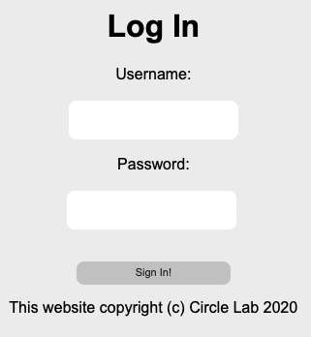

Once you are logged in you will be directed to the below page. Here you are able to select the relevant department to carry out the desired functionality.

Diagnosis Search

The diagnosis page gives you the ability to search for a symptom and see the potential disease that it could be. In addition, the recommend treatments will be listed below each disease.

People Search

Once you have selected the people option you will be directed to the below page.

From here you are able to enter either the first name, surname or full name into the search bar and press enter. This will search the system for a matching record and show you the results as seen below:

Modify Person

From the people results you have the option (see people search) to select the modify button. This will lead you to the below screen:

As you can see by selecting modify person the screen is pre-filled with the selected persons information. Here you are able to modify any details and hit save to update the persons details. This will give you a confirmation that the details have been modified and return you to the people screen.

Deactivate Person

From the people results you have the option (see people search) to select the modify button. By clicking this button, the selected persons account will be deactivated and will not be able to be undone.

Once you have clicked the deactivate button you will be show the below message if the deactivation has been successful.

Add Person

From the people screen you have the ability to add a person to the system. In order to do this, select the add person button.

This will lead you to the below screen:

From here you will be required to enter all the information for that person. Once all information has been entered press the add button in order to add the person to the system. This person will be active from the moment they are added to the system. You will be directed to another screen confirming the person and their details that has been added to the system.

Add Appointment

Coming from the homepage screen, the appointment button will lead you to the below menu:

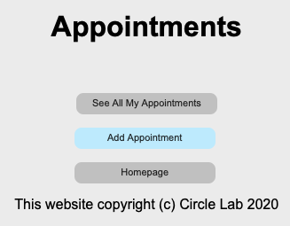

From here you will be able to add a new appointment but clicking the add appointment button. You will be prompted to enter the below details. All of these details will need to be completed in order to add a new appointment.

Once all information has been entered press the add button in order to add the appointment to the system. You will be directed to another screen confirming the appointment and the appointment details that have been added to the system.

See All Appointments / Cancel Appointment

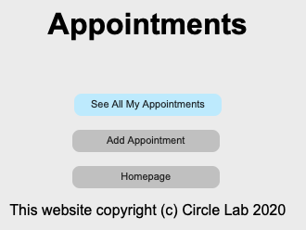

By selecting the “See All My Appointments” button the system will display all the active appointments for the currently logged in user.

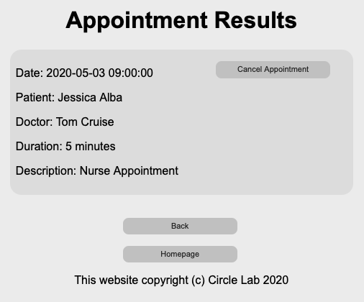

From this screen you will have the option to cancel the appointment. In order to do this, press the “Cancel Appointment Button”. Once you have pressed the button a pop up will confirm that the appointment has been cancelled. Please note that this action cannot be undone, and the appointment will need to be added again if the appointment is deleted by mistake.

Location Search

By clicking the location button on the homepage, you will be directed to the following page:

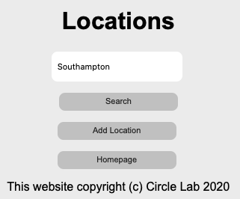

Here you will have the ability to search for a location (for example: Hospital, GP surgery, Pharmacy). You are able to enter with either the locations post code to see more details or if you search for a city you will be given a list of the locations in that city. See below for the example of searching for “Southampton”.

Location Deactivate

After searching for a location (see location search), there will be an option to deactivate the location. Once the location has been deactivated a pop up will appear to confirm that the location has been deactivated. As with person and appointment this action cannot be undone, and the location will need to be re-added.

Add Location

By selecting add location from the location screen you will be directed to an input screen in which the new location details can be added.

With all the details entered you are then able to click the add button. This will direct you to another screen that will confirm the newly added location. All detail will need to be entered in order to add a location. If all the details are not added, you will be notified with an alert that will advise that the location has not been added.

Add Prescription

In order to add a prescription, you are first required to search for a person (see people search). Once you have the people results you have the option to add a prescription to selected person.

Once you have selected to add a prescription you will be directed to the add prescription page. Some of the information will be pre-filled with the patient and the current date but the required drug, quantity and location are required.

The system currently only has the ability to add a maximum of three drugs to a prescription. You must add at least one drug in order to create a prescription. The prescription input screen can be seen below.

Search Prescriptions

If you need to see the current prescriptions, you will need to head to the add prescription menu in order to see the prescriptions for a person.

Here you are able to search for a persons first name, surname or full name. The system will be able to show you all prescriptions for the search criteria (as seen below). From there will also be a button the delete the prescription. If a prescription is deleted is cannot be undone.

